SEO Content Automation with NeuronWriter
n8n | NeuronWriter API | OpenAI | Gemini | Google Sheets

Project Overview
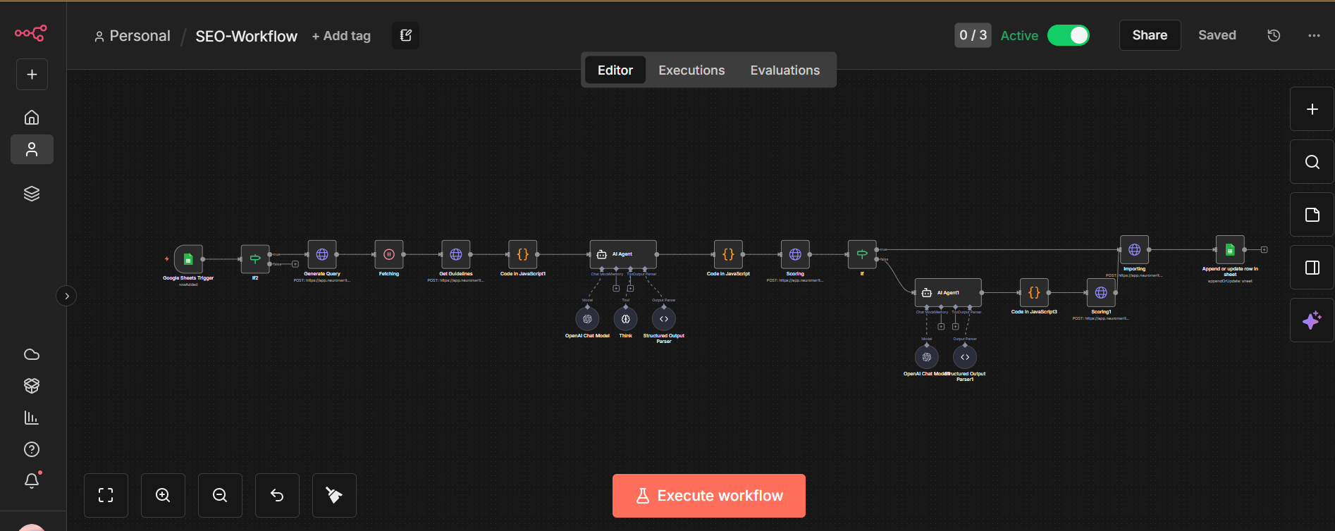
Built an automated SEO content system that generates, checks, and improves articles against NeuronWriter guidelines.
The system takes keywords from Google Sheets, gathers the required SEO information, generates the content, checks the score, and continues refining it until the target score is reached.

Workflow
The process starts with primary and secondary keywords stored in Google Sheets.
The system then:
• Sends keywords to NeuronWriter
• Retrieves SEO guidelines and content requirements
• Generates structured content with the required headings and topic coverage
• Sends the content back for scoring
• Checks the SEO score against the target
• Automatically improves the content when the score is below target
• Saves the final content and SEO data in Google Sheets

Content Optimization
The workflow handles:
• H1 and H2 structure
• Keyword usage
• Semantic topic coverage
• SEO recommendations
• Content refinement
• Score tracking

Technology
• n8n
• NeuronWriter API
• OpenAI
• Gemini
• Google Sheets

Result
A repeatable SEO content pipeline that reduces manual optimization, speeds up content production, and consistently works toward the required NeuronWriter score without having to manually review and revise every article.

